**COLUMBIA COUNTY FIRE** **RESCUE**

**Life Safety Services**

P.O. BOX 1529 Lake City, Florida 32056

Office (386) 758-2120 Fax (386) 754-7064

Fire Inspector

Chief Jeffery Crawford

21 May 2020

TO: Troy Crews

Columbia County Building and Zoning

FROM: Chief Jeffery Crawford

Fire Inspector #136416

RE: New Construction: Capital Metal Supply

A plan review was performed on the proposed new construction for Capital Metal Supply, located on 3798 US Highway 441 South, Lake City Florida 32025. This building was classified under Chapter 12 New Occupancy, of the Florida Fire Prevention Code, 2012 Fifth Edition.

I recommend Approval of the building with the following conditions:

Pending:

* Light Weight Truss Marking
* Florida Statue, Section 633.027, (2008) requires the owner of any commercial, industrial, or multi-unit residential structure of three units or more constructed of light-frame trusses, to install a symbol adopted by the rule of the State Fire Marshal’s Office. This rule establishes the dimensions, color, and location of the symbol to be applied to every commercial, industrial, and multi-unit residential structure of three units or more constructed of light-frame trusses.

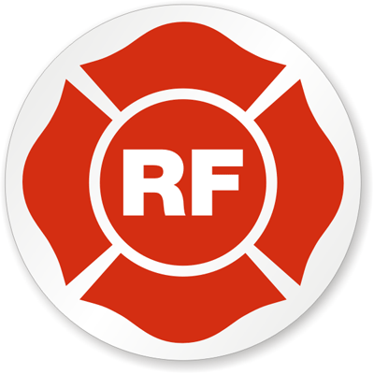

* Emergency Lighting/Exit signs
* NFPA 101 Life Safety Code, Chapter 42.2.9 emergency lighting shall be provided in normally occupied storage occupancies in accordance with section 7.9, except for spaces occupied only during daylight hours with natural illumination in accordance with 42.2.8.2.
* Fire Extinguishers – ABC Fire extinguisher per exit door
* Access Box(es)
  + NFPA 1:18.2.2.1 states, The AHJ shall have the authority to require an access box(es) to be installed in an accessible location where access to or within a structure or area is difficult because of security. The access box(es) shall be of an approved type listed in accordance with UL1037.

Knox Boxes are now a requirement for all new construction

* Electrical Disconnect
  + NFPA 1:11.1.7 states, “means shall be provided for the fire department to disconnect the electrical service to a building, structure or facility when the electrical is covered under the scope of NFPA70.”
  + NFPA 101:7.2.1.5.1 states, “Doors shall be arranged to be opened readily from egress side whenever building is occupied.”

Sincerely,

