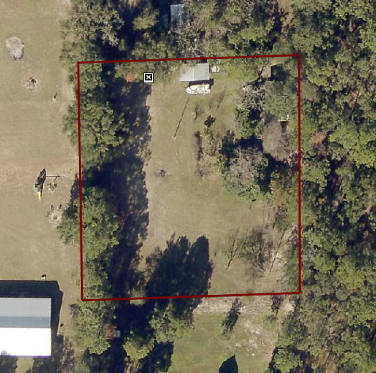

Replacing existing MH on this RSF-2 property.