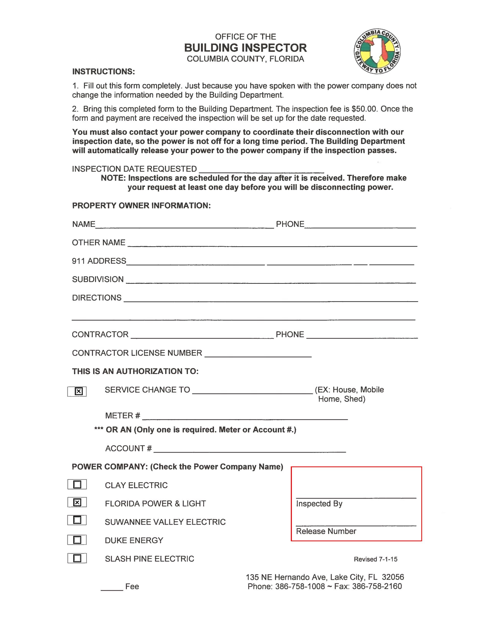Lonnie Gunn

238 NW Madeliene Ter Lake City, FL 32055

Mallard Construction & Electric 352-258-3148

EC-0001917

Mobile Home

401-634-840