**COLUMBIA COUNTY FIRE 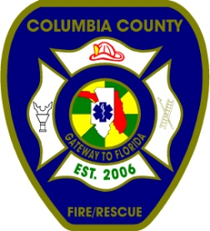RESCUE**

509 SW Bascom Norris Dr., Lake City, FL 32025

Office (386) 754-7071 Fax (386) 754-7064

Cpt. Shane Overstreet

TO: Kingdom Culture Academy

359 SW Dyal Ave.

Lake City, Fl. 32024

FROM: Cpt. Shane Overstreet

Fire Inspector

Florida State Fire Inspector # 256339

RE: Fire Safety Inspection

A fire safety inspection was performed on August 07 2024, at your facility, Kingdom Culture Academy, located at359 SW Dyal Ave., Lake City, Florida 32024. During my inspection, your staff and their commitment to a fire safe facility impressed me. Our Goal for a fire safe community relies on teamwork between you and our staff.

At the time of my inspection, your school meets the requirements as outlined in

Chapter 15, of the Florida Fire Prevention Code, Sixth Edition.

Again, I would like to thank you for your dedication to making your facility a safe environment for your students. Please note that this approval letter is for the classroom portion only. Not to include the restroom portion of the facility.

Should you require any additional information, please feel free to contact my office.

Sincerely,

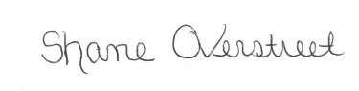

Shane Overstreet