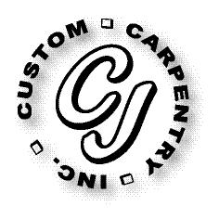***CJ Custom Carpentry, Inc.***

***222 SW Cross Pointe Ct***

***Lake City, Fl 32024***

***386-754-6924 Office***

***CGC1513223***

***Scope of Work***

***Glenn Buckner***

***286 SW PECAN GLEN***

***LAKE CITY, FL 32024***

***Replace front door size for size.***