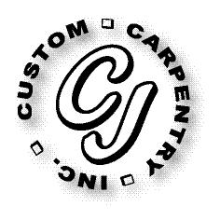***CJ Custom Carpentry, Inc.***

***222 SW Cross Pointe Ct***

***Lake City, Fl 32024***

***386-754-6924 Office***

***CGC1513223***

***Scope of work***

**Customer**

**Konstantin Kapakly**

Replace front door, size for size.