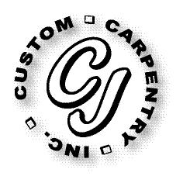***CJ Custom Carpentry, Inc***

***222 SW Cross Pointe Ct***

***Lake City, FL 32024***

***386-754-6924 Office***

***CGC1513223***

**Scope of Work**

1027 NW FRONTIER DR

LAKE CITY, FL 32055

Replace front door and patio door, size for size