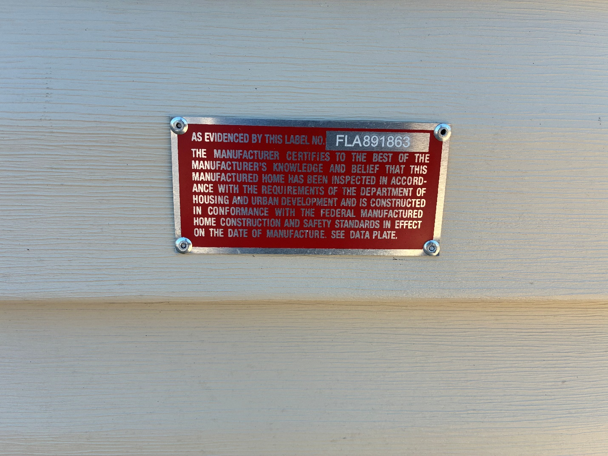
- NO INSTALLER DECAL STICKER.

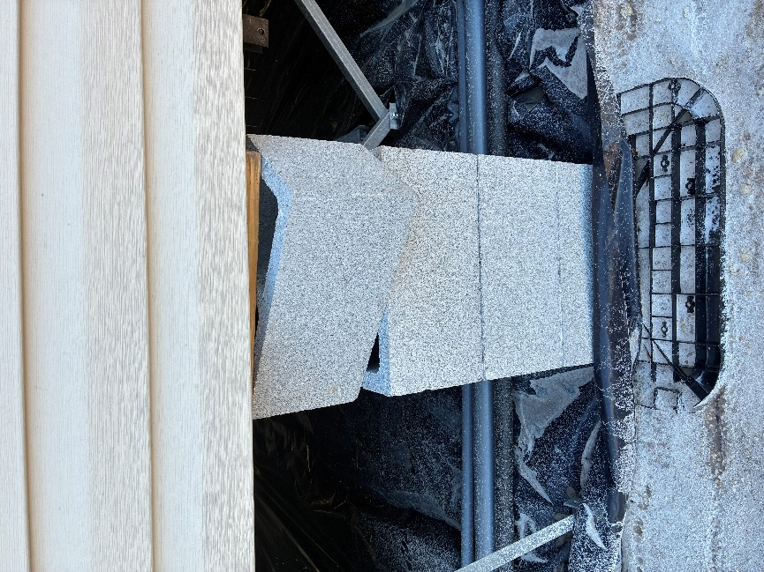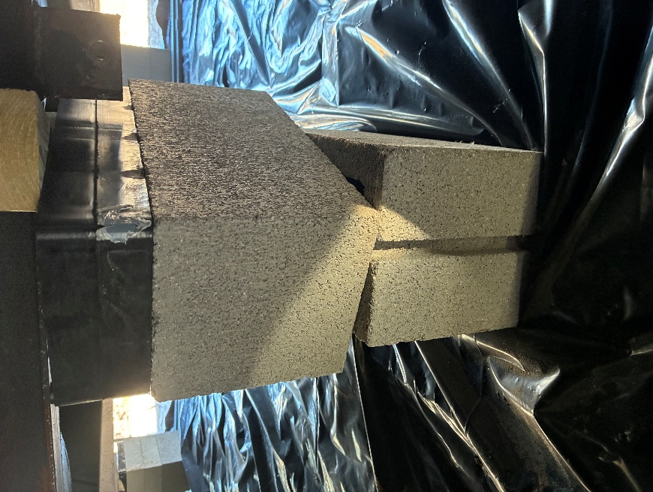
- PERIMETER & MATE-LINE PIERS LOOSE.

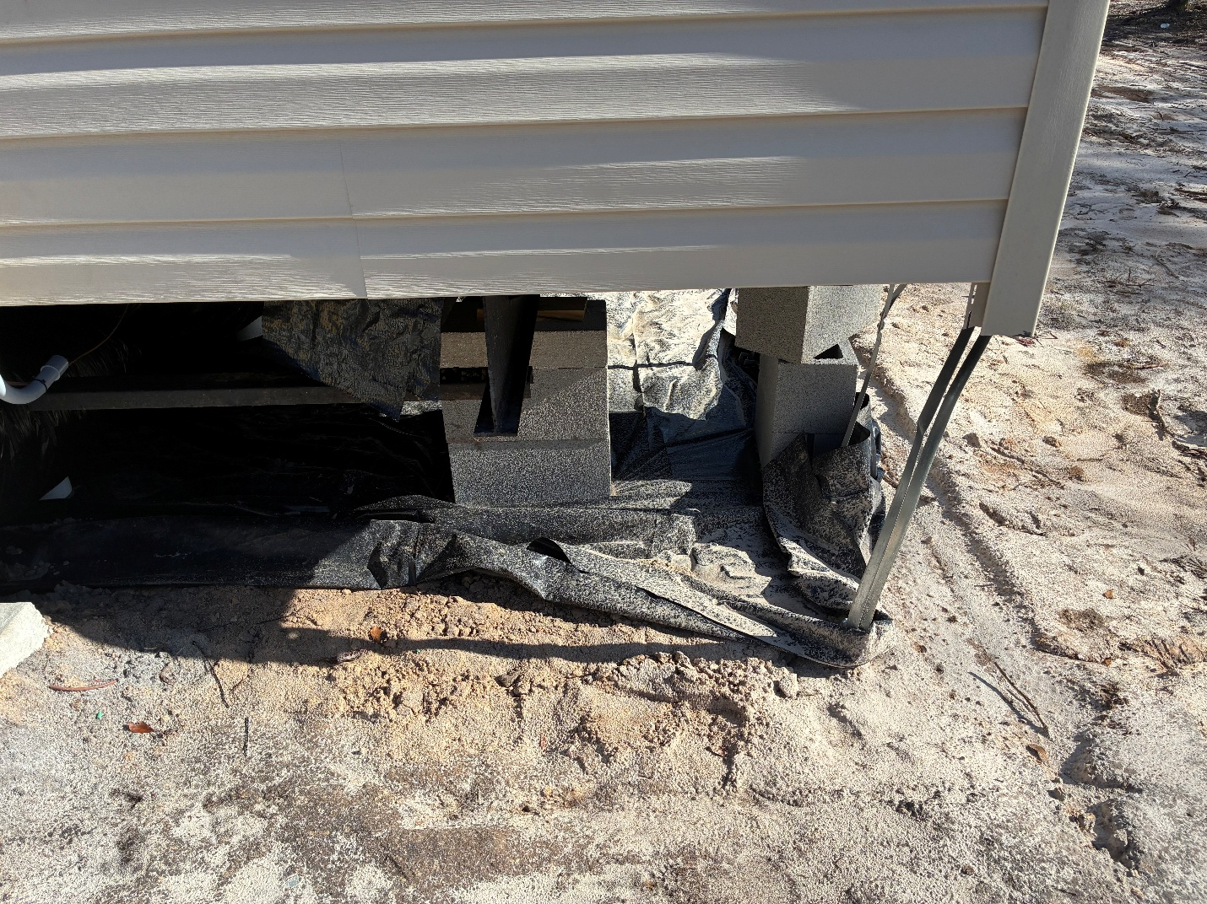
- SHEAR WALL PIERS MISSING AT MANUFACTURER DESIGNATED LOCATIONS, PEIR INSTALLATION DIAGRAM.

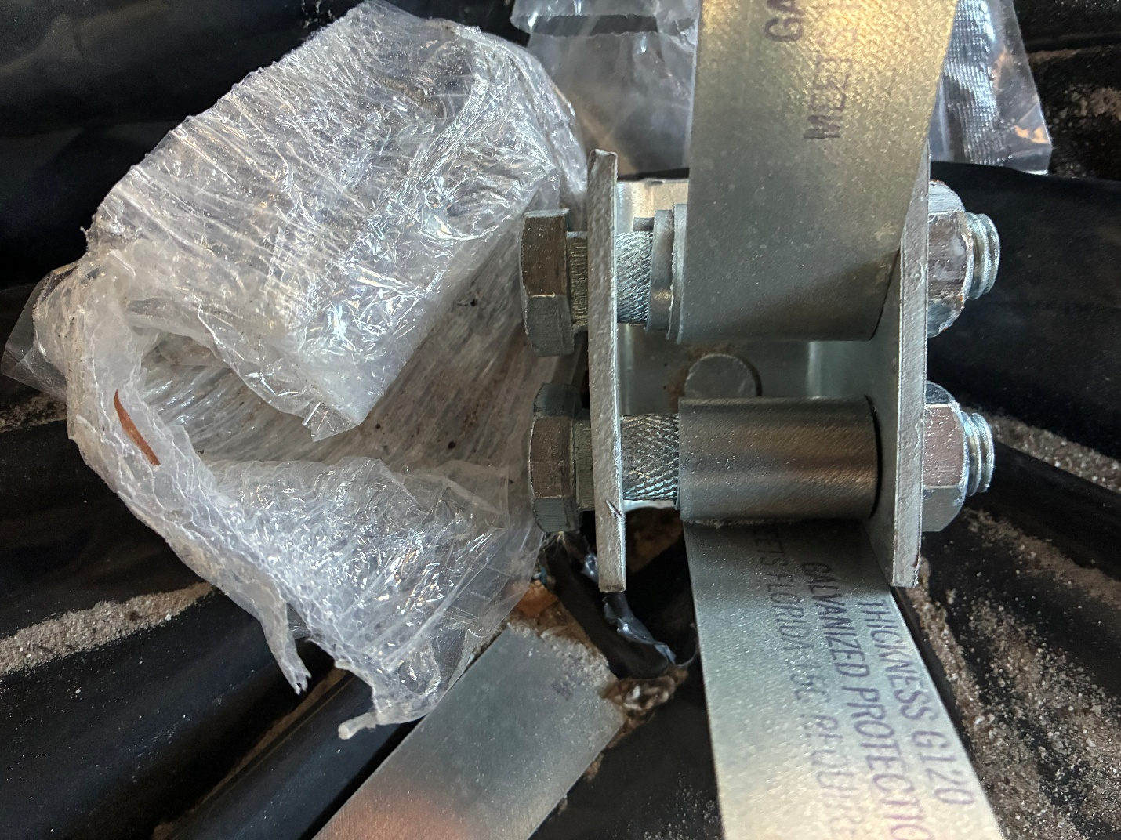
- Slot bolts not properly set into anchor hole.

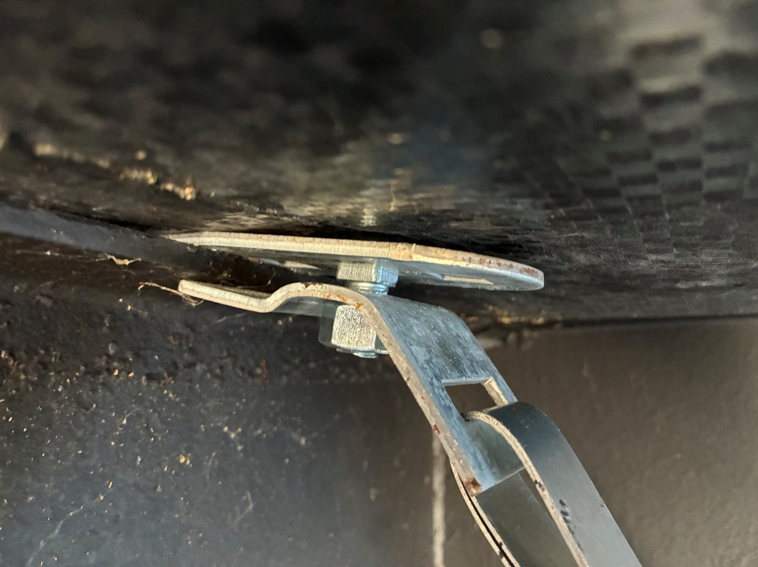
- Loose I-beam clamps at mate-line
- Frame piers at end wall not doubled blocked.
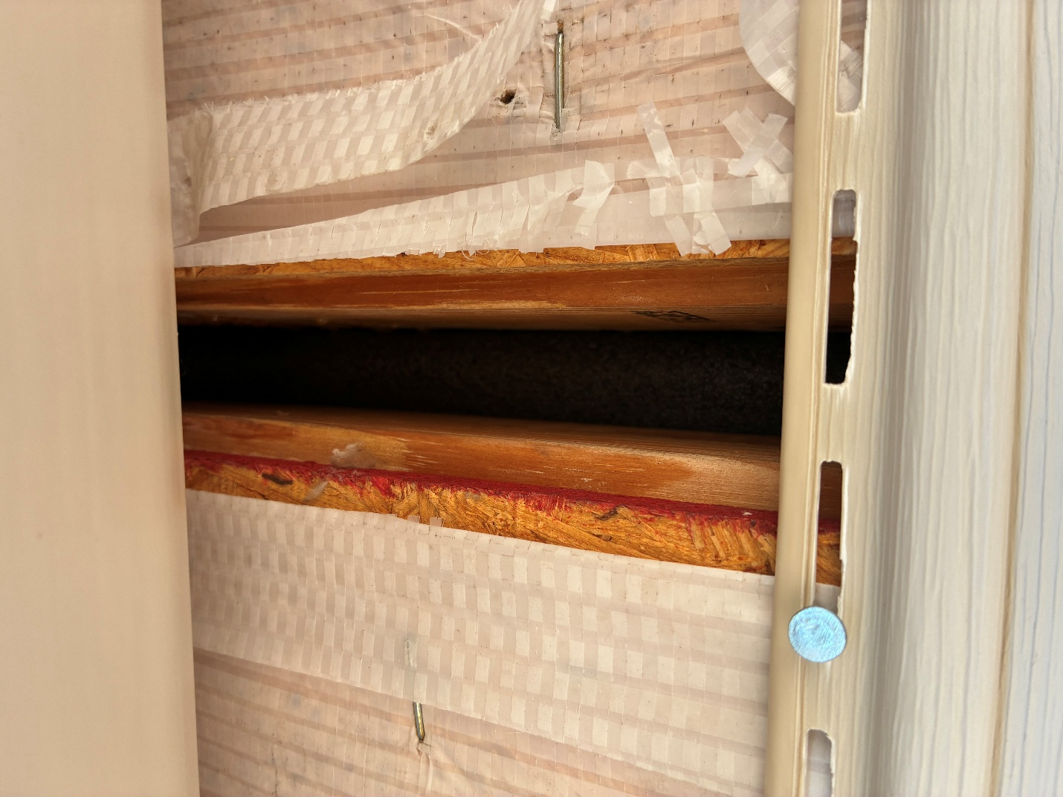
- End wall not fastened
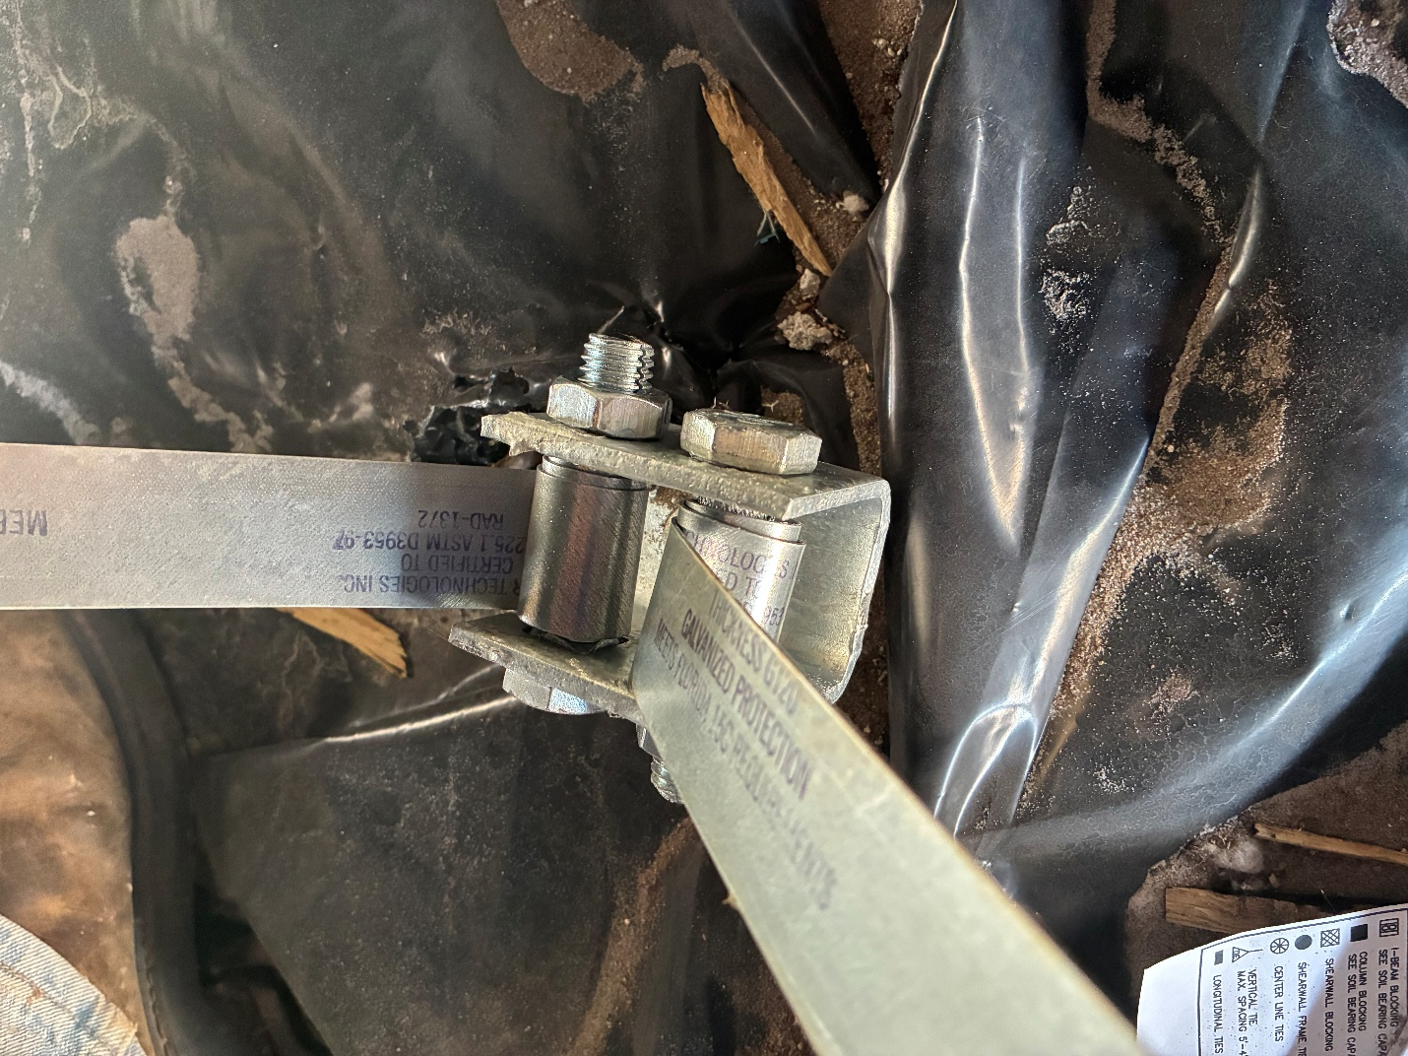
- Anchors only have 2 wraps at slot bolt, multiple locations 3-5 wraps are required.
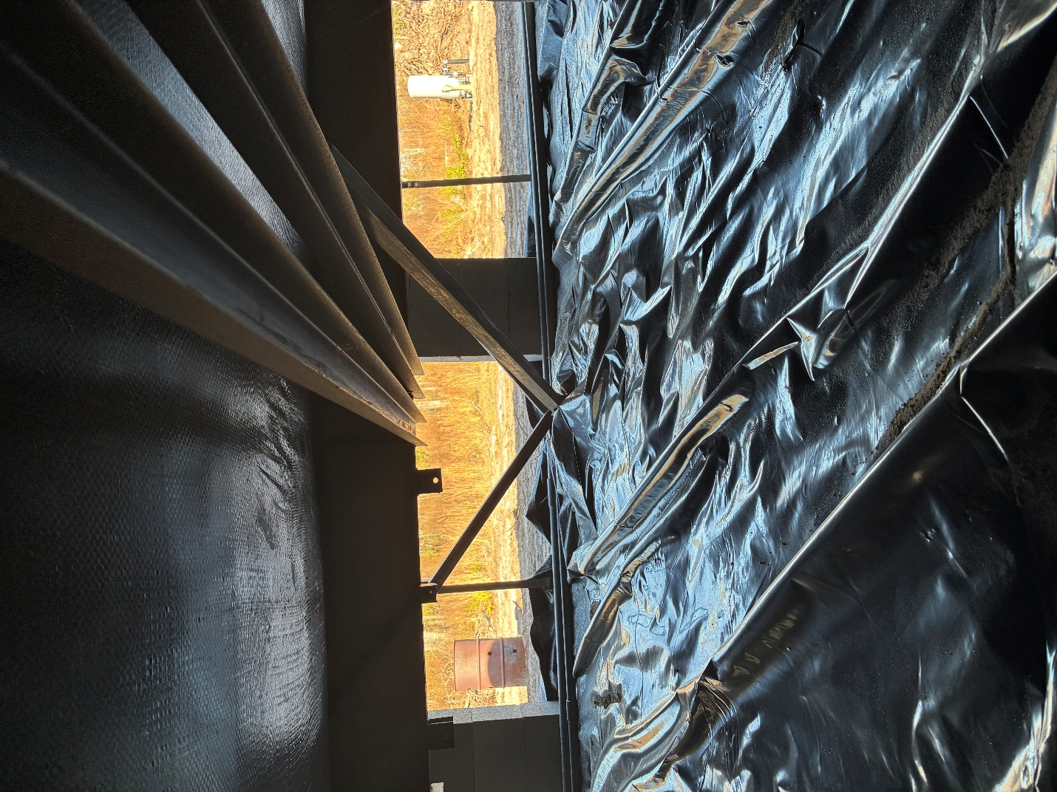
- Oliver 1101V Lateral arm installed out of square to inside I-beam
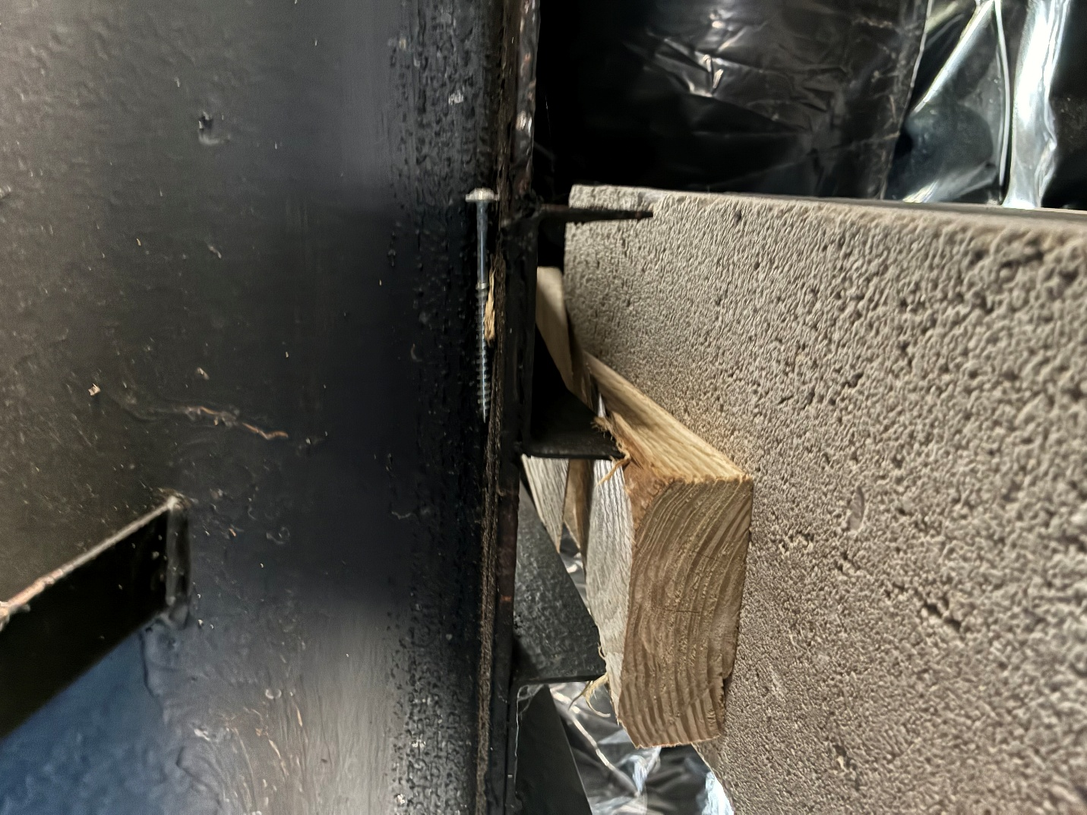
- Frame pier shimmed under crossmember.
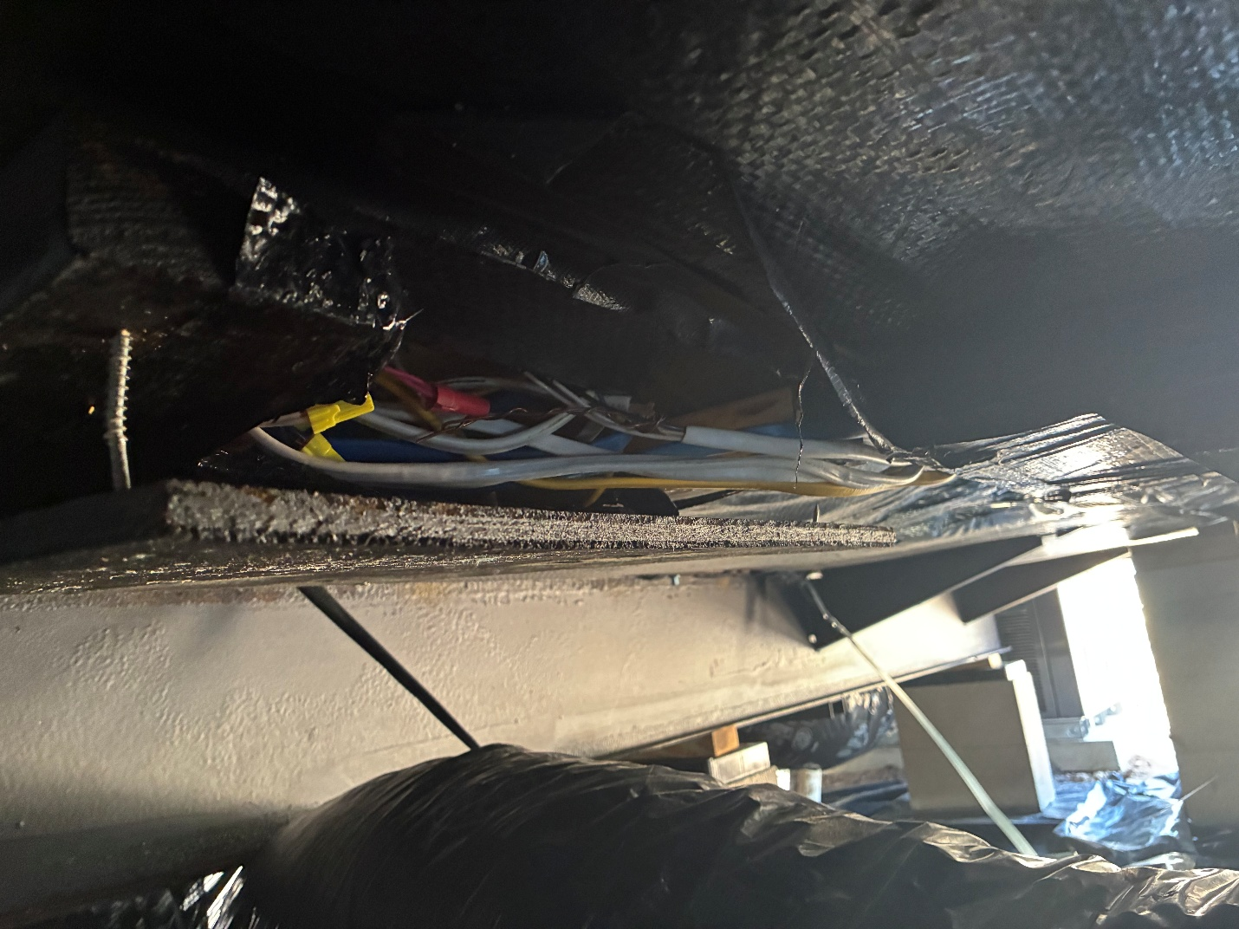
- Electrical wires must not be exposed.
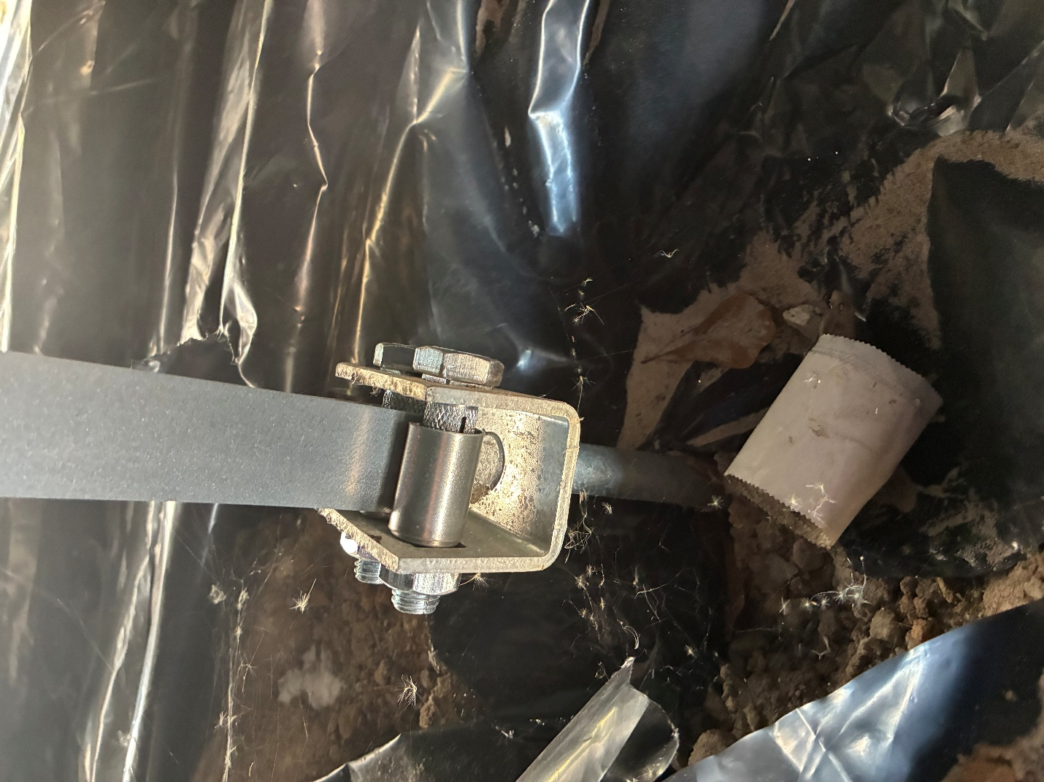
14. Anchors not properly packed at mate-line.
16. Gap at end wall / Mate line exceeds manufacturer allowed spacing, without shimming between modules.

