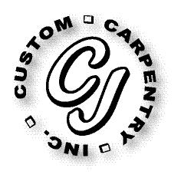
CJ Custom Carpentry, Inc
222 SW Cross Pointe Ct
Lake City, FL 32024
386-754-6924 Office
CGC1513223

Scope of Work
1027 NW FRONTIER DR
LAKE CITY, FL 32055

Replace front door and patio door, size for size

