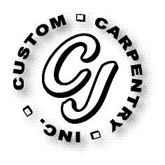
CJ Custom Carpentry, Inc.
222 SW Cross Pointe Ct
Lake City, Fl 32024
386-754-6924 Office
CGC1513223

Scope of work

Customer
Konstantin Kapakly

Replace front door, size for size.

