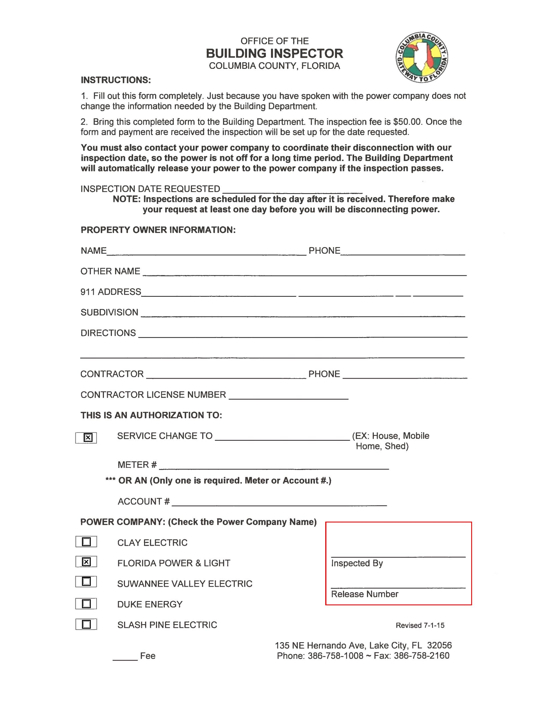
Lonnie Gunn
238 NW Madeliene Ter Lake City, FL 32055
Mallard Construction & Electric 352-258-3148
EC-0001917
Mobile Home
401-634-840

