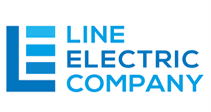

To Whom It May Concern,

In reference to The Woods project and per the meeting with Troy on site, this letter will serve as Line Electrics commitment to not energize the electrical panels to the buildings until the panels have been inspected and approved by the building official. This will allow Panel #1 to be energized by Clay Electric.

Thank you,

Benjamin Sparks
Email: ben@lineelectriccompany.com
Phone: (386) 361-0046
FL LIC #: EC13009101

