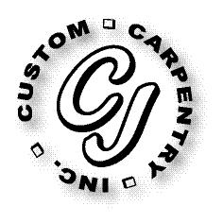
CJ Custom Carpentry, Inc
222 SW Cross Pointe Ct
Lake City, Fl 32024
386-754-6924 Office
386-754-4116 Fax
CGC1513223

Triain Mirov door replacement

Replace front door, dining room, & master bedroom doors, size for size.

