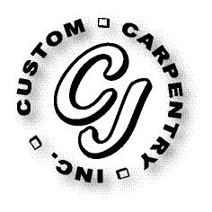
CJ Custom Carpentry, Inc.
222 SW Cross Pointe Ct
Lake City, Fl 32024
386-754-6924 Office
CGC1513223

Scope of Work

Glenn Buckner
286 SW PECAN GLEN
LAKE CITY, FL 32024

Replace front door size for size.

