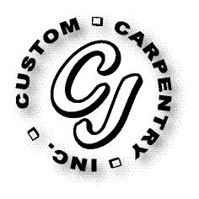
CJ Custom Carpentry, Inc
222 SW Cross Pointe Ct
Lake City, FL 32024
386-754-6924 Office
CGC1513223

Taylor Scope of Work
251 SW Pilots Way
Lake City, FL 32024

Replace Side Entry & Back Entry doors size for size

